**A Project Report**

**on**

**OPTIMIZING DELIVERY ROUTES USING MACHINE LEARNING AND GRAPH THEORY**

***by***

***ACCESS DENIED***

***TEAM MEMBERS***

***MARY JASMINE M***

***VAISHNAVI T***

***ASHA S***

***NIBYSHA A***

***(Bachelor of Engineering in Computer Science and Engineering)***

**Project Report**

**1 INTRODUCTION**

**1.1 Overview**

* Global transportation sector is one of the most difficult to decarbonize.
* Perhaps an effective method is route optimization, as passenger and freight transportation are responsible for about half of transport GHG emissions and much of this mileage occurs inefficiently which ultimately increases the amount of traffic on the roads.
* Route optimization is the process of finding the best and most cost-effective route for delivery drivers.

**1.2 Purpose**

* The delivered project consisted of building a solution to find optimal routes for a fleet of vehicles that either deliver packages picked from a depot to a set of sites, or pick up and deliver packages from and to a set of locations; while honoring a set of constraints:

1. Vehicle start and stop locations (longitude and latitude).
2. Vehicle capacity: the maximum capacity of items they can transport.
3. Pickup time interval for each pickup location (start and end times in HH:MM, e.g. 08:00 to 14:00).
4. Dropoff time interval for each drop off location (start and end times).

**2 LITERATURE SURVEY**

**2.1 Existing problem**

* Electric vehicles are often cited as a mitigation strategy for Greenhouse Gas (GHG) emissions.
* But there are other factors to take into account that go from the material used in batteries and electronic equipment, to whether the infrastructure for the distribution of electrical energy depends on fossil sources.

**2.2 Proposed solution**

* By using optimization routes we can reduce the use of vehicle which reduce the decarbonization and our web app is used to analyze the travel distance by the vehicle and their routes used for delivery.
* Route optimization is perhaps a better fix, as freight transportation increases traffic on roads and is responsible for about half of GHG emanations.

**3 THEORITICAL ANALYSIS**

**3.2 Hardware / Software designing**

**Hardware requirement:**

* Windows 11
* CPU – intel i5

**Software requirement**

* Visual studio code
* Python compiler

**3.1 Block diagram**

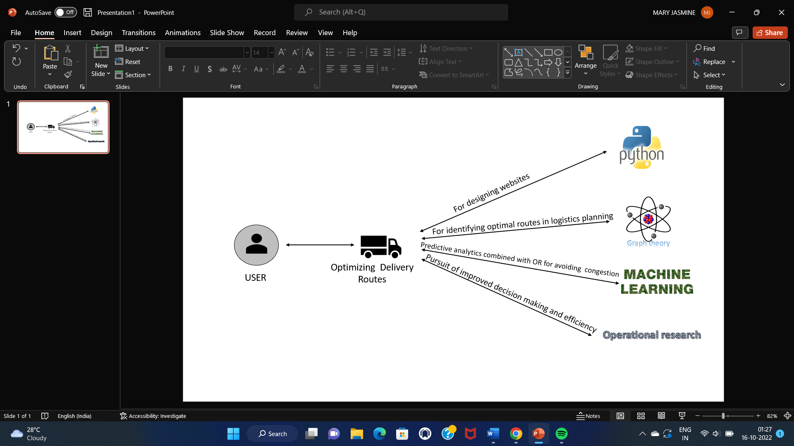

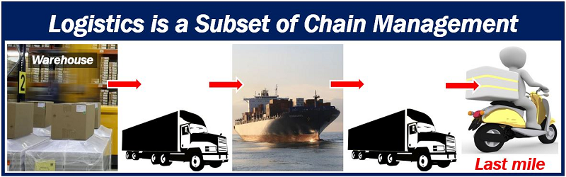

**4 EXPERIMENTAL INVESTIGATIONS**

* Initially we had very smaller number of datasets, which covers limited areas. Then we added some more datasets to get the desired output.
* We are adding a total distance covered by a specific vehicle and total number of rides covered by a single vehicle.

**5 FLOW CHART**

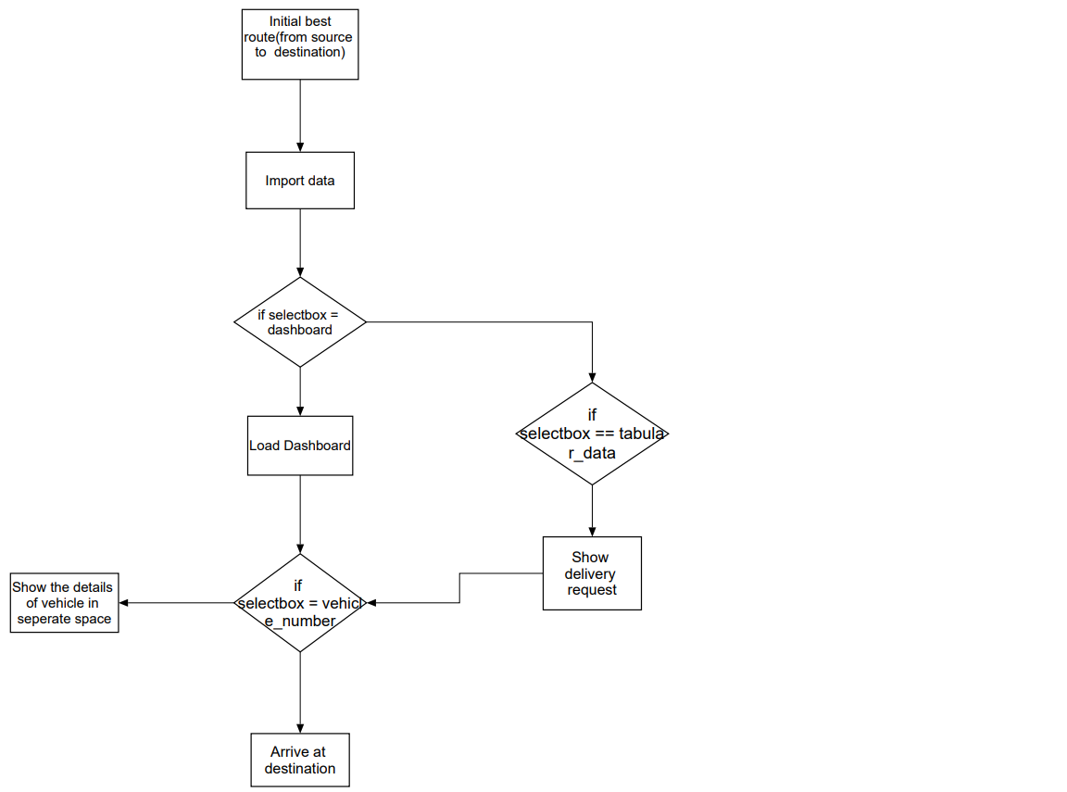

**6 RESULT**.

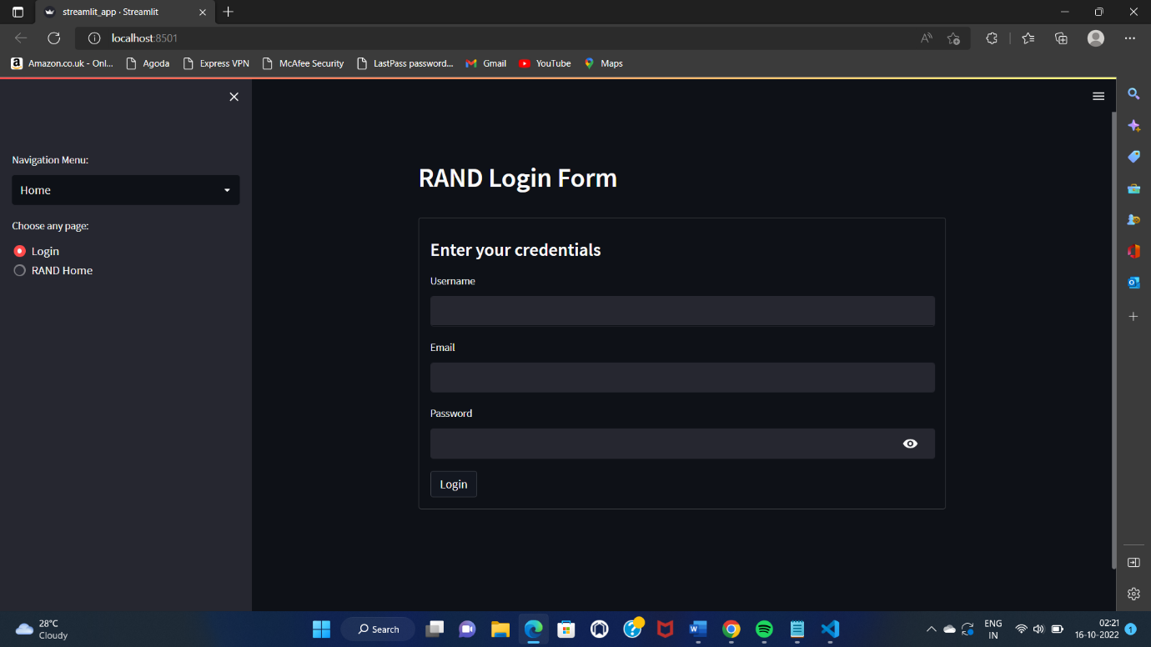

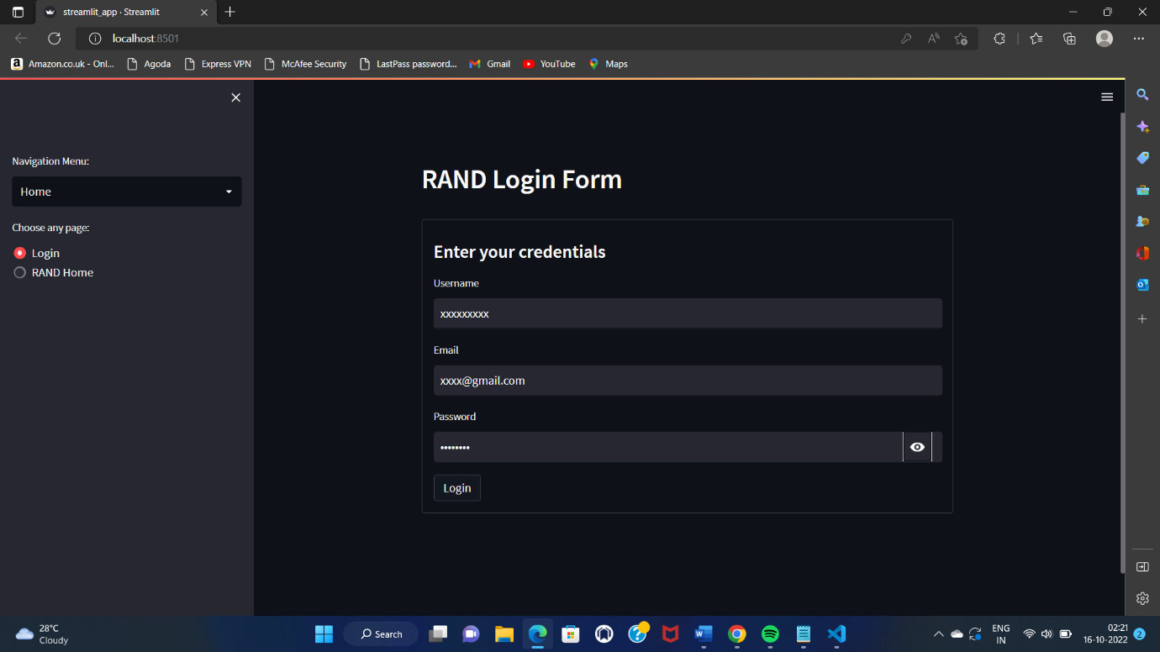

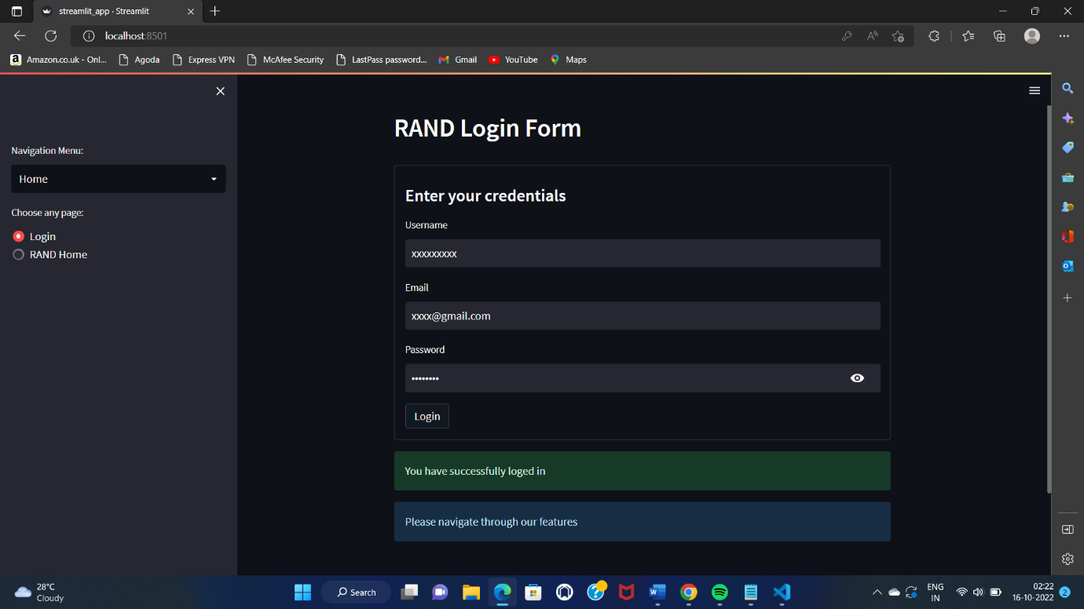

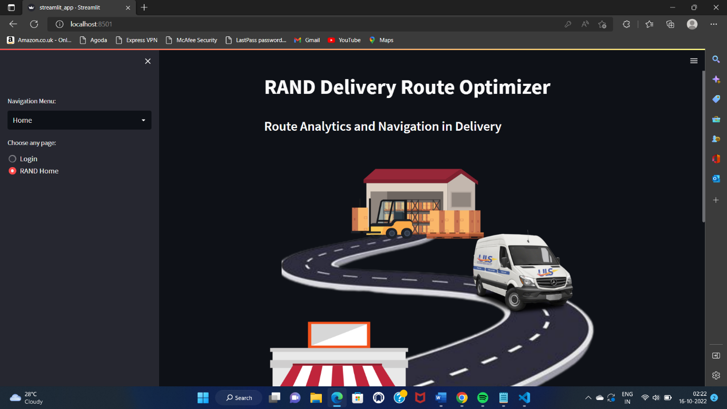

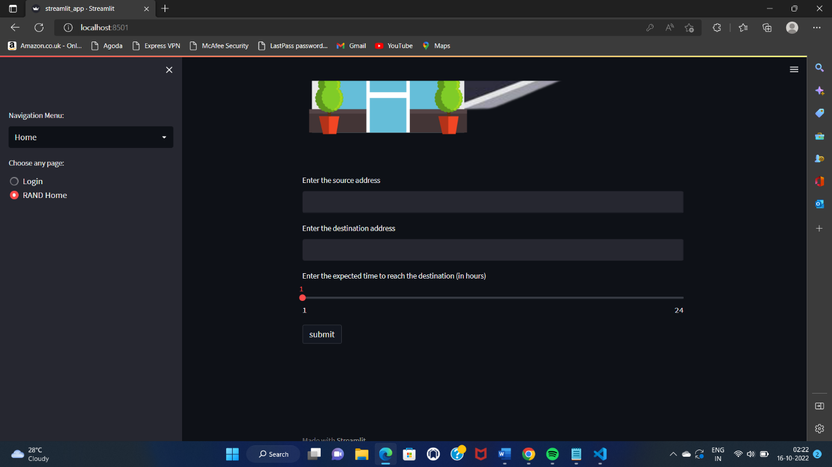

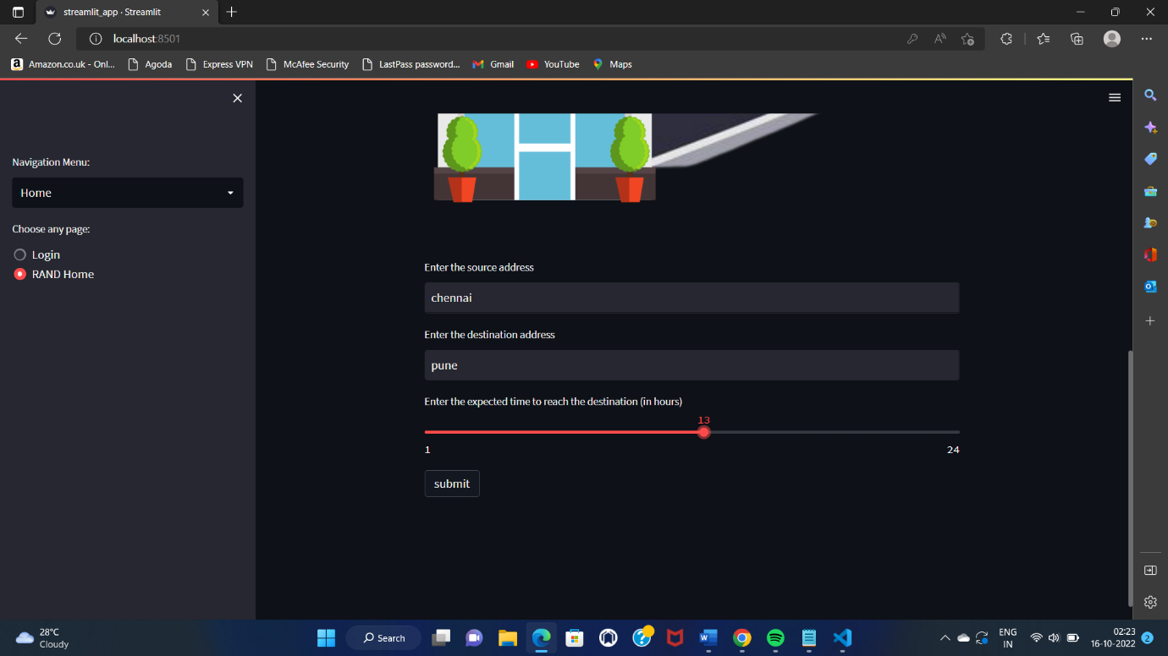

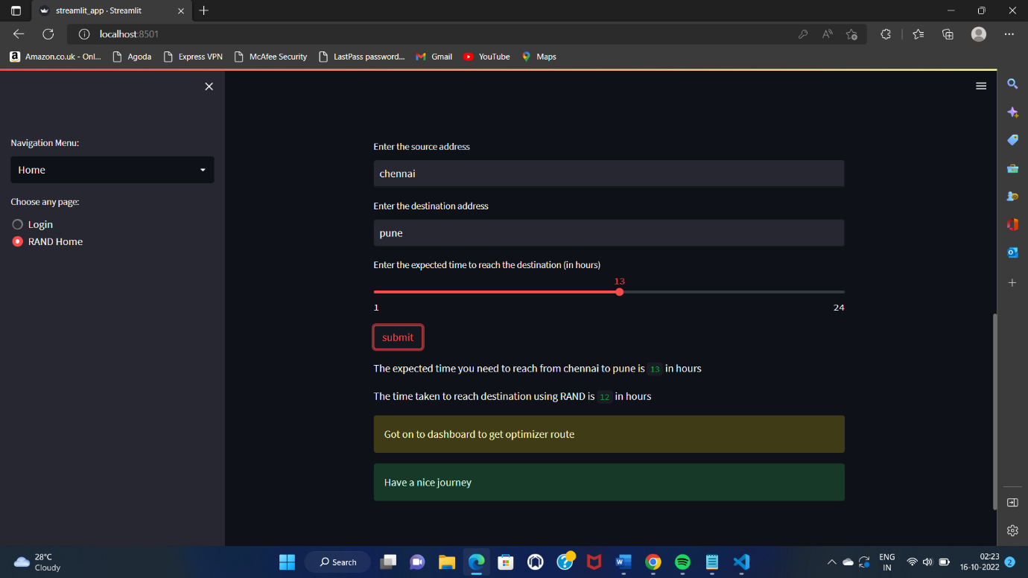

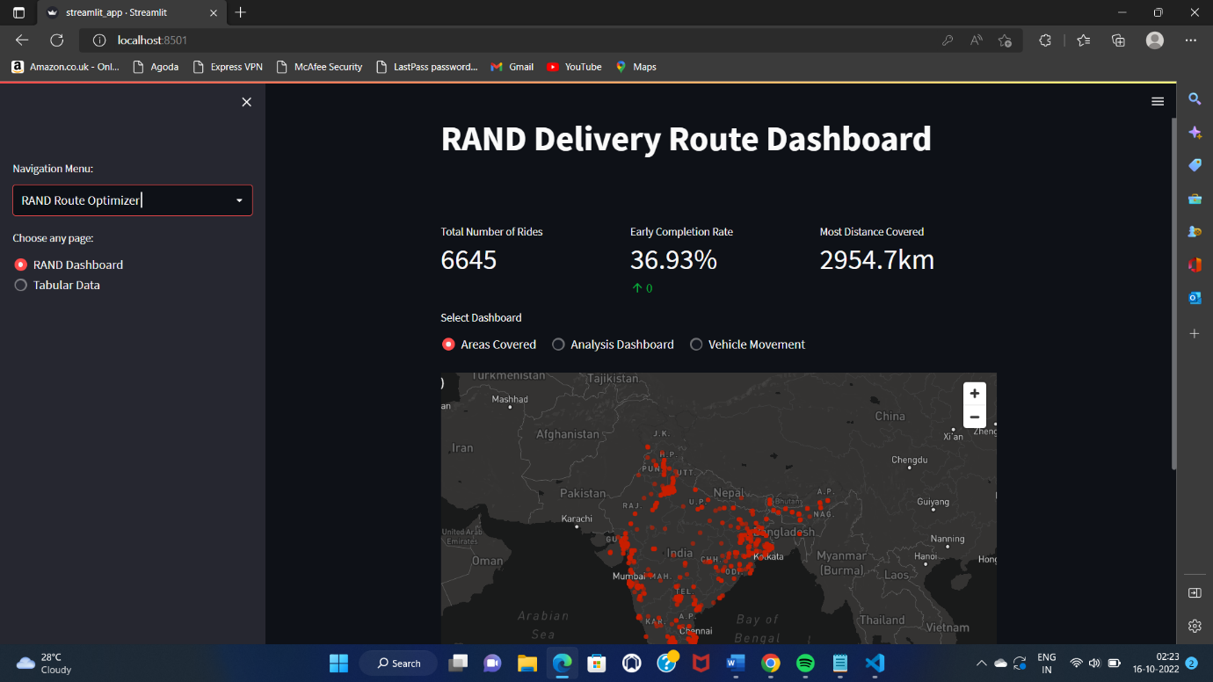

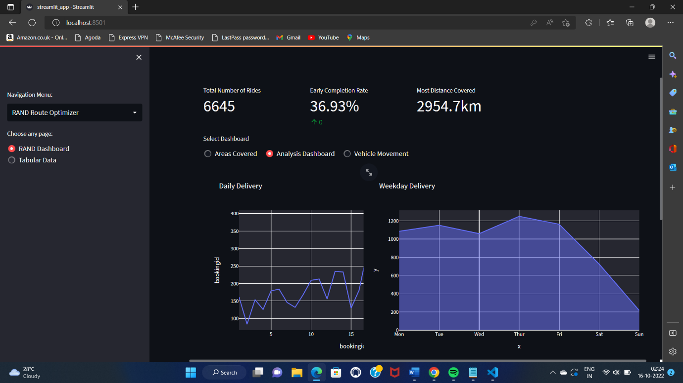

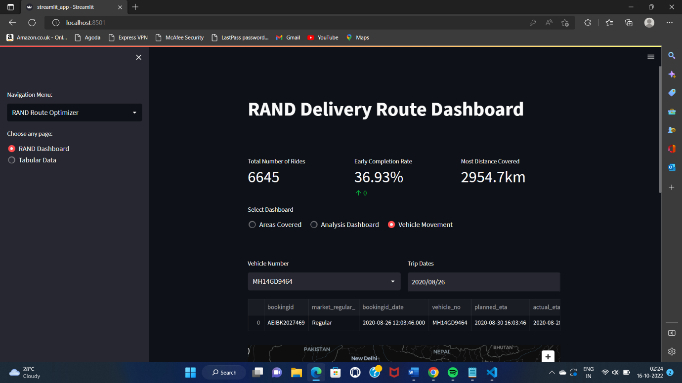

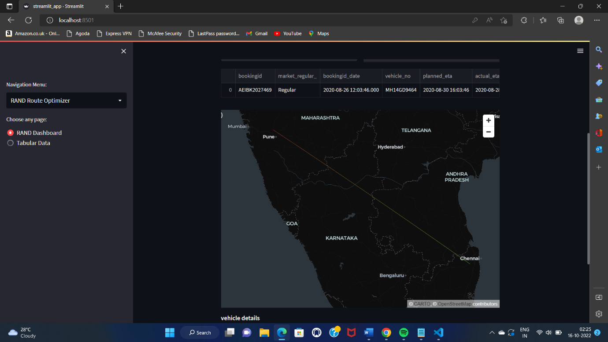

**7 ADVANTAGES**

**Benefits of route optimization**

* Route planning helps distributors and businesses with delivery operations plan out the best routes for their drivers each day, whether they are trying to provide reliable ETAs and improve customer satisfaction or get through a multi-stop delivery route in the most efficient way possible.
* Optimal routes mean your drivers spend less time driving, which reduces fuel costs and can increase the number of stops a driver can make in a day, which can help improve your bottom line.

**DISADVANTAGES**

* They have not reached the minimum level of digitalization required to consider implementing it (this is sometimes the case for small businesses).
* They believe that the potential benefits from optimizing their routes (versus manual planning) are not worth it.
* They believe that their activity has too many specific constraints to be taken into account by a route optimization software

**8 APPLICATIONS**

* It can be used by the salesman who used to deliver the things or food to the destination (i.e) to your location.
* Route optimization is perhaps a better fix, as freight transportation increases traffic on roads and is responsible for about half of GHG emanations.

**9 CONCLUSION**

* The transportation sector is one of the most difficult to decarbonize. Different approaches have been proposed in order to mitigate GHG emissions such as ride-sharing and autonomous vehicles. But due to the Jevons Paradox those solutions may potentially worsen the situation.

**10 FUTURE SCOPE**

* In future we are also develop this to find route by considering traffics on the roads.
* Monitor driver’s availability and requirements by location.

**11 BIBILOGRAPHY**

<https://youtu.be/4NLahglMWoo>